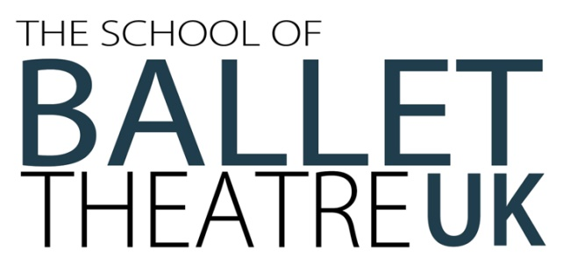

Thank you for your interest in The School of Ballet Theatre UK’s Associate Programme.
How to Apply
Entry to The School of Ballet Theatre UK’s Associate Programme is by audition only.
Successful applicants will be invited to audition to our audition day. Places are offered from this audition, there will not be any re-call auditions.
Because of the high demand of applicants each year, The School of Ballet Theatre UK has a policy that we are unable to provide individual feedback.
Returning your completed form
Please return the following to the address below; or email to kate.stubley@btukschool.com
- Fully completed application form, including all signatures.

- Photographs (no larger than 6x4), in classical uniform, as follows:
- Facing away from the camera, feet together in parallel.
- Facing forward, tendu à la seconde with arms in seconde.
- Facing the side, 1st arabesque en l’air.
The Student’s name should be written on the back of all photographs.
Address:
The School of Ballet Theatre UK, Leicestershire House, The Borough, Hinckley, Leicestershire, LE10 1NL

Audition Fee
The audition fee of £40 must be paid via BACs/bank transfer.
Evidence (a remittance slip or equivalent) must be supplied with the application form.
Payment details are as follows:
The School of Ballet Theatre UK
Sort Code: 40-24-19
Account Number: 31860623

Questions and Queries
If you have any questions or queries regarding your application, please do not hesitate to contact our auditions coordinator, Mrs Stubley, via email or telephone.
Email: kate.stubley@btukschool.com
Telephone: 01455 254921

Whilst great care is taken over the safety of all dance students throughout the course, The School of Ballet Theatre UK cannot accept responsibility for any injuries or illness sustained during or after the audition.

Affix headshot photo here.

Associate Programme 2026/27
Application Form
Please complete using BLOCK CAPITALS

Applicant Details
Full Name
Date Of Birth
Age September 2026

Parent/ Guardian Details
Full Name(s)
Address
Telephone Number
Email Address

Please State which parent/guardian is the main contact for correspondence:
How did you hear about The School of Ballet Theatre UK?
Source | Details (Please specify who/ what)
Advertisement
Teacher
Former Pupil
Current Pupil
I saw Ballet Theatre UK perform
Social Media
Other

I would like to attend the audition on; (Please Tick to Confirm)
Sunday 17th May 2026
Deadline for Application: 13/5/26

Current Dance School Details
Dance School Name
Teacher Name(s)
Email Address

Dance Experience
Please complete the below table.
Genre | Hours taken per week | Most Recent Examination Taken  (Please include the syllabus studied, date taken and results)
Ballet
Pointe Work
(If applicable)

Please complete a short personal statement below including your achievements in dance so far, your ambitions for your future career and why you wish to attend The School of Ballet Theatre UK’s Associate Programme.
Previous Injuries or Medical Conditions
I can confirm that the above information is correct to the best of my knowledge.
Applicant Signature
Parent/ Guardian Signature
Date

